

***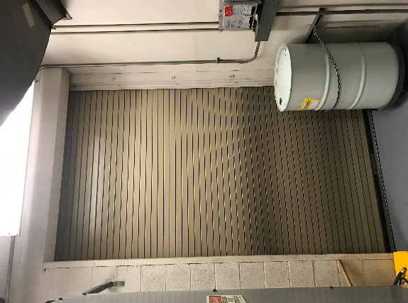*PM SERVICES FOR ROLLING STEEL & COUNTER FIRE DOORS:**

**VISUAL INSPECTION:** Conduct a visual inspection for anything that may cause a hazard during testing or affect proper operation or resetting.

**Verify that:**

1. Mounting and assembly bolts are not missing or loose.

2. Welds and weld locations comply with installation method for fire door assemblies welded to

steel jambs per manufacturer’s installation instructions.

3. Fusible links are located per manufacturer's instructions.

4. Guide assemblies have the required fire expansion clearance per manufacturer's instructions.

5. Fusible links and sash chain/cable links are not painted or coated with dust or grease, cable is

**Rolling Steel Fire Door**

not kinked or pinched, chain is flexible and not twisted, and raceways are not obstructed.

6. Smoke detectors/release devices function properly.

7. Nothing that is not a part of the fire door assembly is attached to any part of the fire door

assembly (suspended ceiling, light fixtures, ducting, conduits, framing and any other building materials).

**Check for damaged or missing components:**

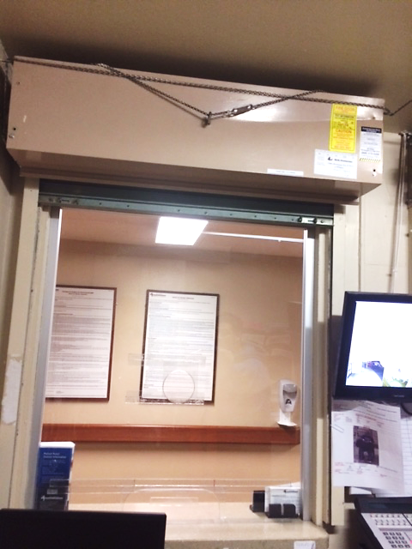1. Slats – bent/tears or holes/metal fatigue.

**Counter Fire Door**

2. End Locks – missing/broken/ bent/loose.

3. Bottom Bar – bent angles; loose bolts.

4. Guide Assembly – bent angles or channels; loose bolts; curtain entry misalignment.

5. Hood (and Flame Baffle when required) or Fascia – bent; rubbing curtain; holes; loose

fasteners; metal fatigue; missing intermediate supports (when required).

6. Automatic Closing Mechanism – missing, broken parts; drop or release arms tied, blocked or

wedged.

7. Operating Mechanism – worn, misaligned or poorly meshed gears; worn roller chains;

misaligned or loose sprockets; loose bearings; broken parts; bent shafts.

*The drop tests, reset, repairs and/or maintenance should be performed by a trained door system technician with complete knowledge of this type of fire door and the manufacturer's instructions. Repair parts must be obtained from the original door manufacturer. After repairs are completed, the door must be tested to assure proper door operation and automatic closing capability. The fire door must be in the fully open position before the drop test. Reset the door following the drop test and test again. Contact Barr Commercial door and we can help you meet these requirements!*

***REQUEST FOR ROLLING STEEL & COUNTER FIRE DOORS: Please fax/email this form to: (909)503-1664 or service@barrdoorcorp.com***

**DATE: ________________TIME: _______________ NEW CUSTOMER? : YES / NO**

**COMPANY: _______________________________________________**

**FIRST & LAST NAME: ________________________________________**

**REFERRED BY:**

**___________**

**CONTACT: ____________________ ALT. CONTACT: ____________________**