

**PM SERVICES FOR GRILLES AND GATES:**

* 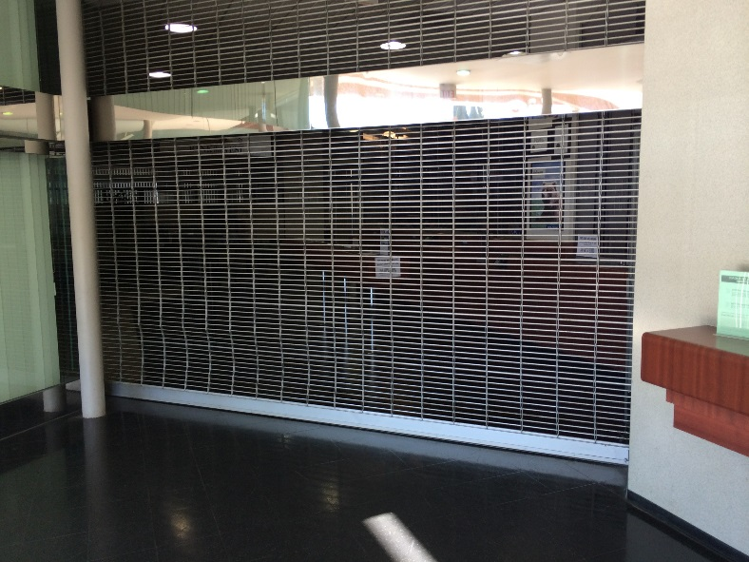Check general operation of system
* Assess condition of driveway
* Inspect structural state of gate support
* Inspect cable ducts and access where possible
* Inspect condition of gates
* Check gate alignment and ground clearance
* Inspect general condition of hinges, gate stops and other gate furniture
* Grease hinges
* Inspect operators for condition, damage, wear etc.
* Check operator fixings, brackets and geometry
* Assess performance of operators and clutch settings
* Bleed and top-up oil
* Pressure test and adjustment – open and close
* Check manual release and locking performance
* Check protection of electrical connections to operators
* Assess system usage levels
* Assess Logic, Run, Pause, Leaf Delay and Over-run times
* Carry out electrical inspection and earth insulation test on motors and their cables
* Inspect isolation and protection of mains power supply
* Check if RCD is present
* Check electrical connections, terminations and protection
* Check earthing termination
* Check condition and operation of all control equipment
* Check sealing of control box
* Check sealing of Audio Link, photocells and other control equipment
* Clean Audio Entry panel
* Clean out foundation boxes and check drainage for under gate operators
* Check and if required, change batteries on Safety Edge and Photocell Transmitters
* Highlight any areas of concern and provide appropriate recommendations
* Check, affix and date service sticker

***REQUEST FOR ROLLING STEEL & COUNTER FIRE DOORS:***

***Please fax/email this form to: (909)503-1664 or service@barrdoorcorp.com***

**DATE: ________________TIME: _______________ NEW CUSTOMER? : YES / NO**

**REFERRED BY:**

**___________**

**COMPANY: _______________________________________________**

**FIRST & LAST NAME: ________________________________________**

**CONTACT: ____________________ ALT. CONTACT: ____________________**